Knots
Square Knot-
‘Right over left, left over right. Makes a knot secure and tight’.
Kids will get one rope, not two. So make sure they understand that they need to keep their pinkies and ring fingers in the bottom loop so that they can achieve the knot.

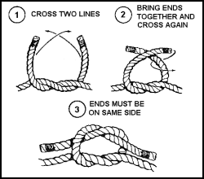

Taut Line Hitch- slides.
Often taught without a stick. Keyword to use is ‘P’ (step 0-1), ‘R’ (step 2)
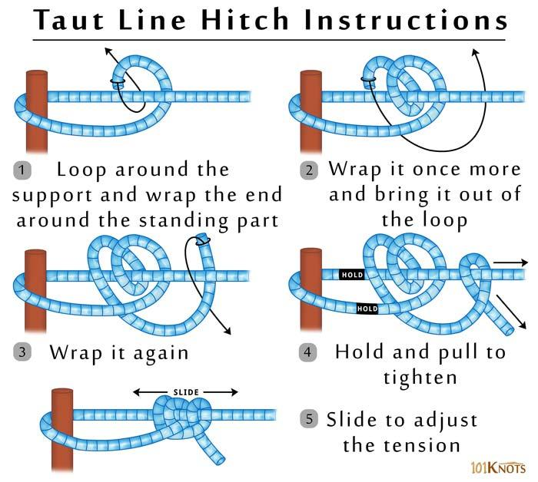
Bowline- Creates a fixed loop to hook around things.
A keyword to help kids remember is ‘pot of gold’ (step 1-2).

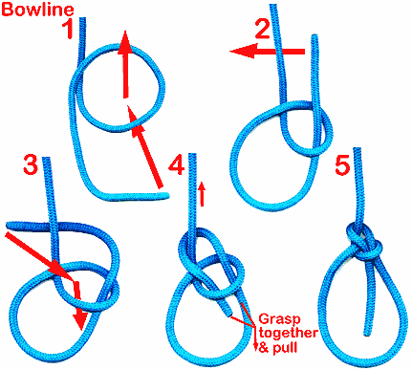

Clove Hitch- used to tie something to an object. Useful if pair kids up, and have on tie while the other holds the stick.
