Knife Safety
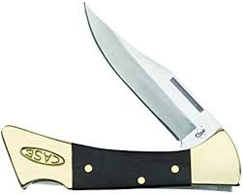
Basic Rules:
- Keep knife closed when not using it.
- Only use when in a safety circle.
- Open and close knife with the sharp part of the blade sticking up.
- Close knife with the palm of your hand.

Passing an Open Knife:
- Hold the top of the blade, with the blade facing down. Curl your fingers, so that they are not wrapped around the whole blade. This is so that if the knife falls, you will not be cut.
- The person receiving the blade grabs the handle, and says ‘Thank You’.
- The person giving the knife, should not let go until they hear the phrase ‘Thank You’.

Quiz -
Should be done as a group. Can have them all answer using thumbs up for True and down for False, or call on kids to answer. After determining a sentence false, please rephrase the sentence to be true and have kids repeat the corrected sentence.
- You should close the blade with the palm of your hand. | True | False
- It’s okay to keep your knife wet. | True | False
- It’s OK to keep your knife dirty as a badge of honor. | True | False
- A sharp knife is safer than a dull knife. | True | False
- You should carry your open knife in your pocket. | True | False
- Carving your initials into a tree is okay. | True | False
- My friends and I should not sit near each other when using our knives. | True | False
- A knife is a toy. | True | False
- A dull knife is more likely to slip and cut you. | True | False
- When passing my pocket knife, I should hold the blade. | True | False
- Always cut toward you, not away from you. | True | FALSE
- I can pass the knife open or closed. | True | False

