Fire-
Edible Fire Components:
- Cup of Water - Bucket of Water
- Spoon - Shovel
- Marshmallow or Red Hot - Fire Starter
- Coconut - Tinder: dry and fluffy small pieces. Used to start the fire. Moss, wood chips, twigs.
- Pretzel Sticks - Kindling: Makes the fire bigger without smothering it or making it too big too soon. Sticks, usually placed in an A-frame to allow air flow.
- Cheetos - Fuelwood: keeps the fire burning. Logs or big sticks.

Types:
- TeePee: used for warmth and long lasting
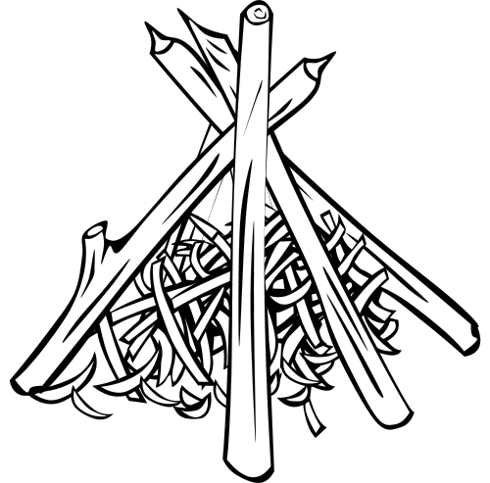
- Log Cabin: used to cook
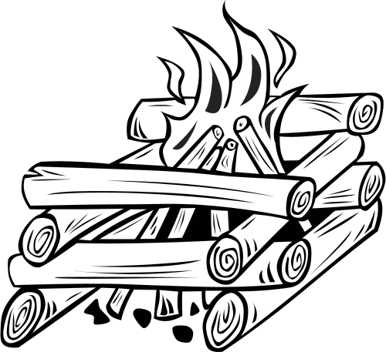
Cooking-

Charcoal Chimney: hollow metal cylinder without a top or bottom. Has slits around the bottom to allow air to flow through. Place a fire starter on the bottom and surround it with coals. Light the fire starter from outside the can through the holes. Can use two fire starters placed throughout the coals to ensure all the coals become hot and that the fire starters are not smothered.
- Each briquette (piece of charcoal) is worth about 25℉
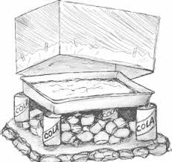
Box Oven: used instead of a real oven.
Making a Box Oven-
- Use a big box as your oven
- Cover the holes with duct tape.
- Smooth the foil over the inside of box with the shiny part facing inwards. Secure foil to outside of box with tape. Repeat until there are at least 3 layers of foil. No part of the inside of the box should be exposed.
Using an Oven- same temperature and time given on directions.
- Cover the area of ground you will be using with the 3 layers of foil.
- Start Charcoal Chimney
- When coals are red and beginning to turn white remove can and spread coals out.
- Place 4 small cans around the coals, but close enough to balance a pan on.
- Place the pan of food onto the small cans.
- Place the box over pan, and prop up with a rock to allow air to keep the fire going.

Dutch Oven: large cooking pot with lid.
- Twice the diameter is the number of coals needed to reach 325℉. Then add one briquette for every 25℉ until reaching desired temperature.
Using an Oven-
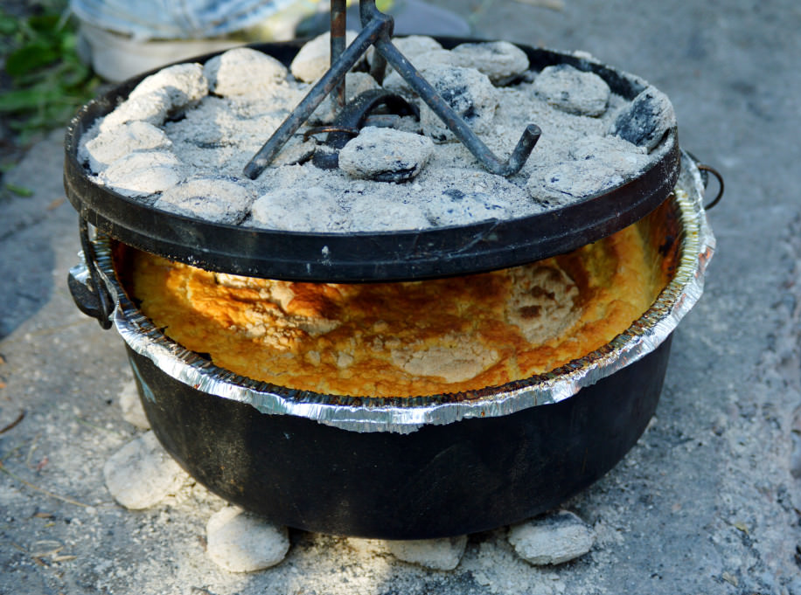
- Cover the area of ground you will be using with 3 layers of foil.
- Start Charcoal Chimney.
- Depending what you are making, cover inside of the dutch oven with foil, to make clean up easier.
- When coal are red and beginning to turn white, remove can and spread out the coals. Set aside about half the coals or ⅔ if you are baking.
- Place the dutch oven onto the spread out coals. Place the set aside coals on the lid of the dutch oven.

